Purification des eaux de surfaces

Rétention des sédiments

Analyse Primaire

Marc-André Blais

Avril 2024

Introduction 2

Travaux Connexes 2

Données 2

Méthodes proposée 2

WS 3

Tetrad 3

Machine Learning 3

WS Benefit 4

Tetrad 4

Machine Learning 4

SR 4

Tetrad 4

Machine Learning 4

SR Benefit 4

Tetrad 4

Machine Learning 4

NR 4

Tetrad 4

Machine Learning 4

NR Benefit 4

Tetrad 4

Machine Learning 4

PR 4

Tetrad 4

Machine Learning 4

PR Benefit 4

Tetrad 4

Machine Learning 4

Discussion 4

Conclusion 4

# Introduction

# Travaux Connexes

# Données

# Méthodes proposée

## WS

Water storage capacity

### Tetrad

Model 6 in annex 1.1

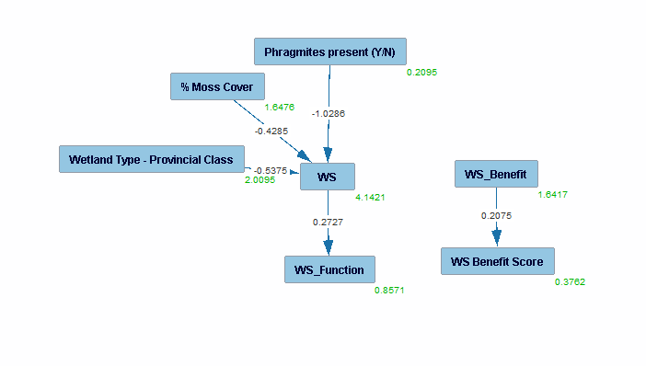

NoMo entry, knowledge (4) tiers modified with score-function tiers, PC-mb with WS as target, graph, PM, Estimator, Custom graph

### Machine Learning

## WS Benefit

### Tetrad

Model 6 in annex 1.1



NoMo entry, knowledge (4) tiers modified with score-function tiers, PC-mb with WS as target, graph, PM, Estimator, Custom graph

### Machine Learning

## SR

### Tetrad

NoMo entry, knowledge (4) tiers modified with score-function tiers, PC-mb with Ws as target , graph, PM, Estimator, Custom graph

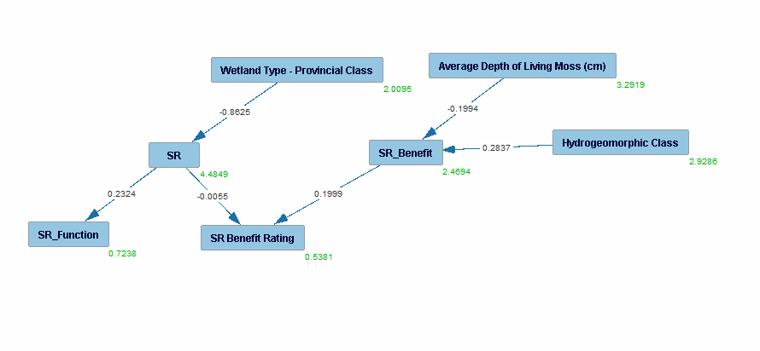

### Machine Learning

## SR Benefit

### Tetrad

NoMo entry, knowledge (4) tiers modified with score-function tiers, PC-mb with Ws as target , graph, PM, Estimator, Custom graph



### Machine Learning

## NR

### Tetrad

NoMo entry, knowledge (4) tiers modified with score-function tiers, PC-mb with Ws as target , graph, PM, Estimator, Custom graph

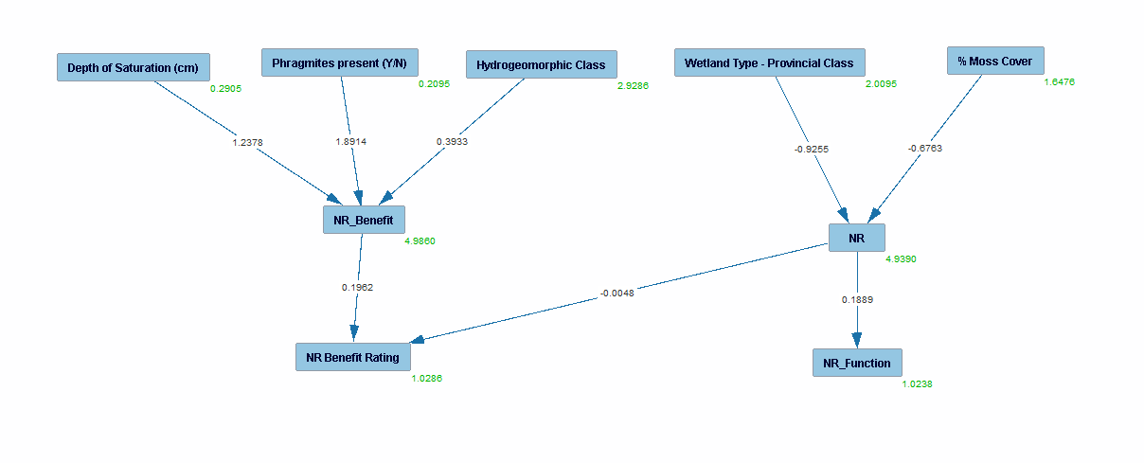

### Machine Learning

## NR Benefit

NoMo entry, knowledge (4) tiers modified with score-function tiers, PC-mb with Ws as target , graph, PM, Estimator, Custom graph



### Tetrad

### Machine Learning

## PR

NoMo entry, knowledge (4) tiers as previous with forbidden, PC-mb with Ws as target , graph, PM, Estimator, Custom graph

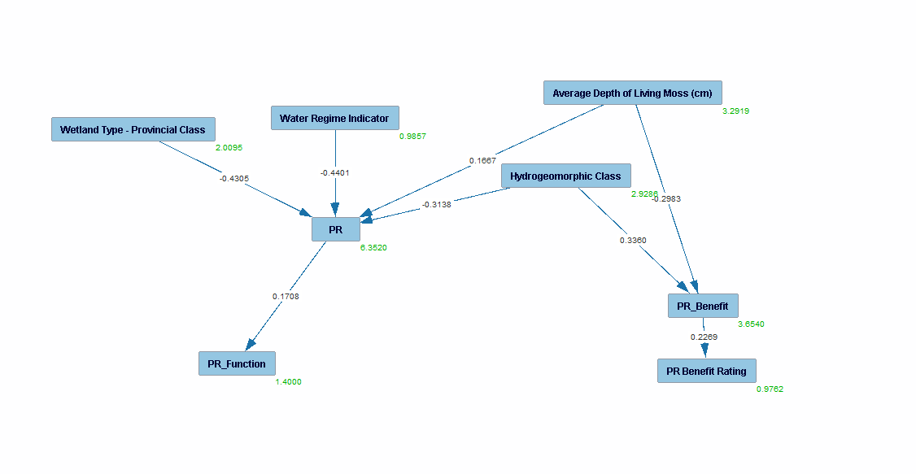

### Tetrad

### Machine Learning

## PR Benefit

### Tetrad

NoMo entry, knowledge (4) tiers as previous with forbidden, PC-mb with Ws as target , graph, PM, Estimator, Custom graph



### Machine Learning

# Discussion

# Conclusion

Notes rencontre (À modifier)

comptabilisation du carbone (Chronologie), données frag., donnée utilisable une fois comptabilisé mais peu importante en ce moment

Tourbière (profondeur) pas important atm

Priorité:

-Purification des eaux de surfaces, spatialisé, rétention des sédiment avec indicateur (sol rugueux, desnioté végétation)

use charactéristique in model to determine rétention des sédiments SR/PR/NR

Réduction dimentionalité pour calculer scores (pour déduire F/M/E)

-Risque d'innondation (water storage) WS/SFTS

-Maintien des écoulements de base (Castor)

-Stockage Carbone

Prochaines étapes: Collecte de données, débuter rapport